Collaborating on GitHub

1. Open the local repository of the github repository and change from feature-login to main branch.

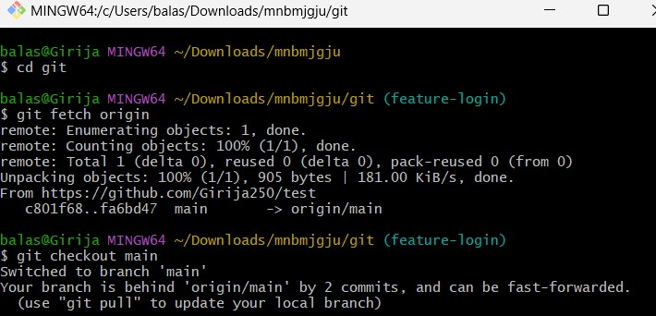

1. Check the changes made in the branch.

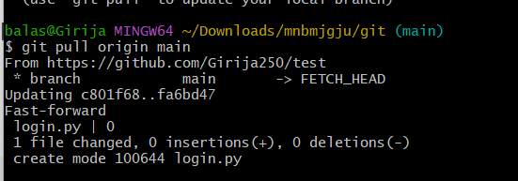

1. Now create a new branch named feature-new.

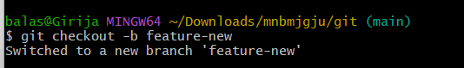

1. Now commit the changes in the repository by creating a new file or updating the file.

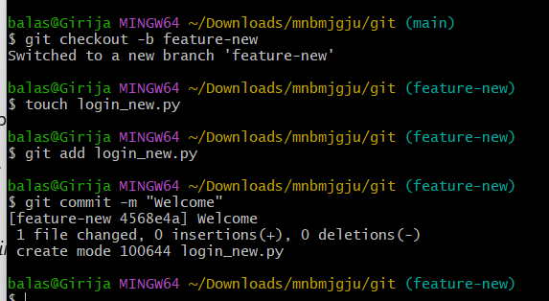

1. Push the changes to the github repository.

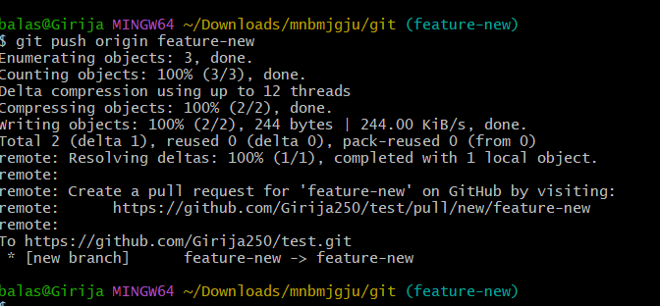

1. Open the specific repository in github and click on popup notification of pull request.

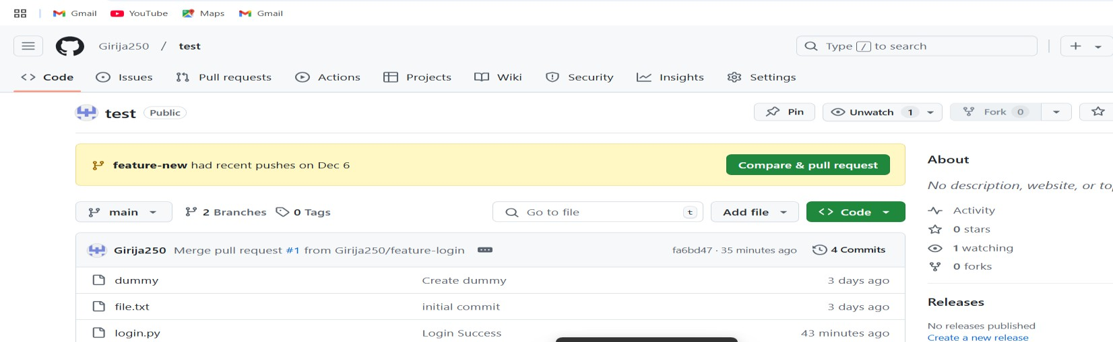

1. Give title and description for the pull request.Click on the create pull request.

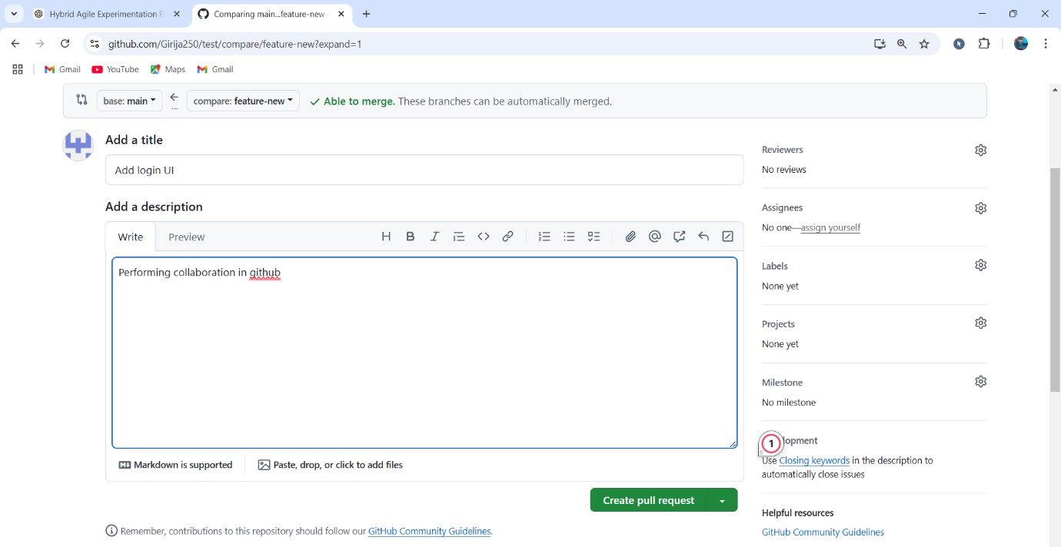

1. Observe successful pull request and click on merge pull request.

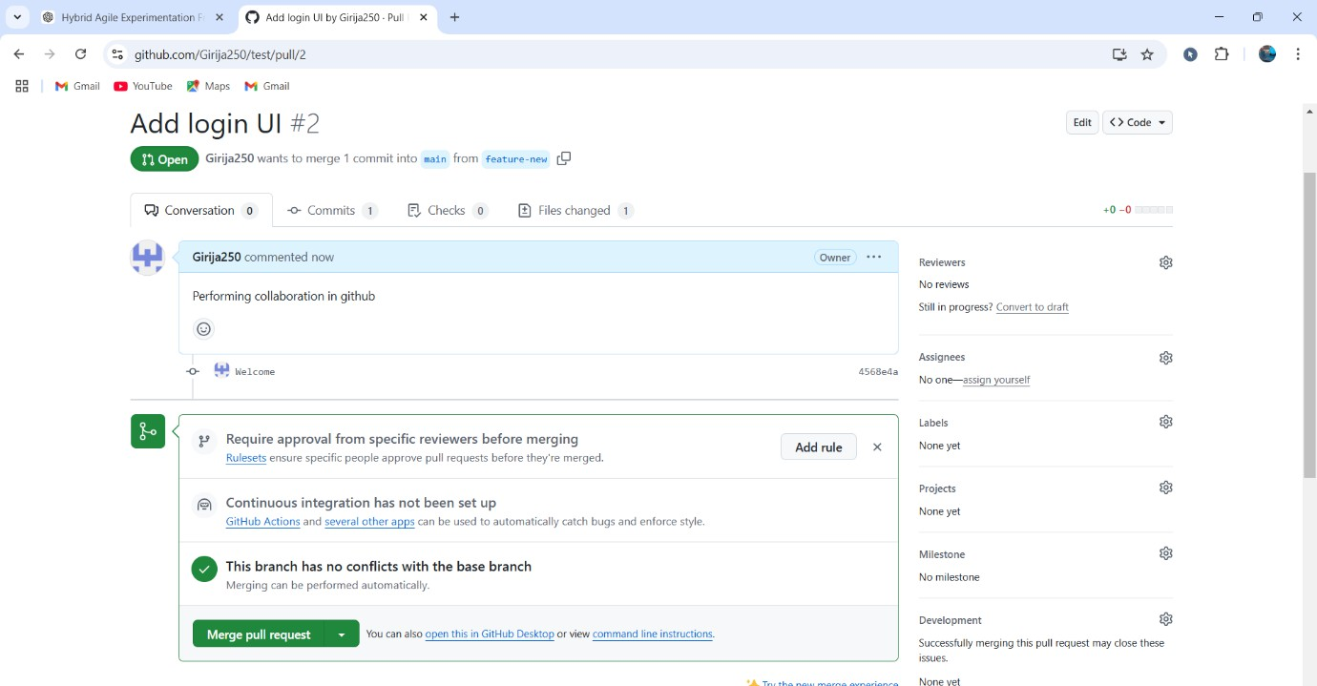

1. Verify the successful pull and merge of collaboration.

